Texting Candidates in Phenom
- Under the client's name, the hiring manager selects the contact info button to show the candidate's contact information defined in the CRM.
- Selecting the three-dot actions button brings up a menu where hiring managers selects:
  - Send SMS (Candidate must have opted-in for SMS and your organization must have SMS)
  - Note about the other options on this menu:
    - Invite the candidate to interview (Must have AI Scheduling)
    - Upload an attachment. Uploading an attachment appears in the candidate profile both in Hiring Manager and your CRM.
  - 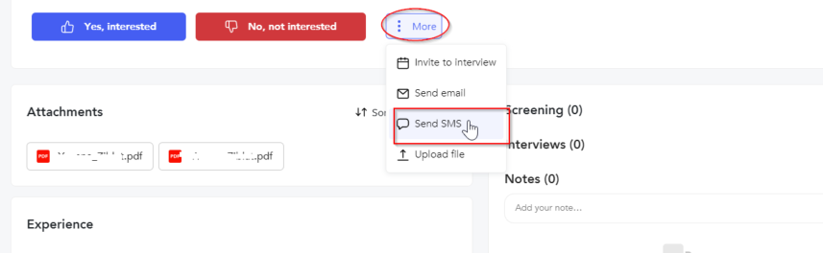
- Select a local area code to the store location. This cannot be changed later:
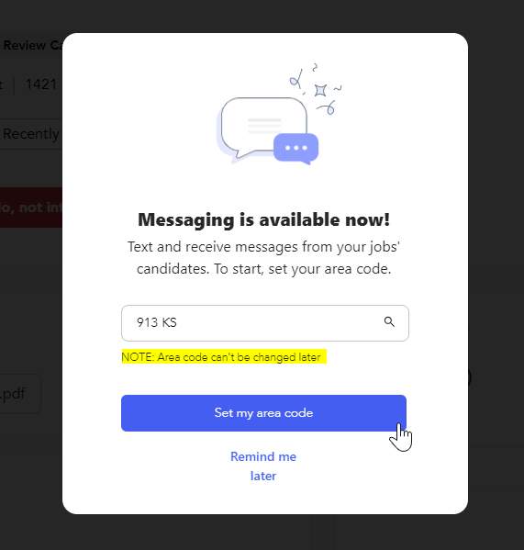
- Text from the platform to engage candidates and schedule interviews:
